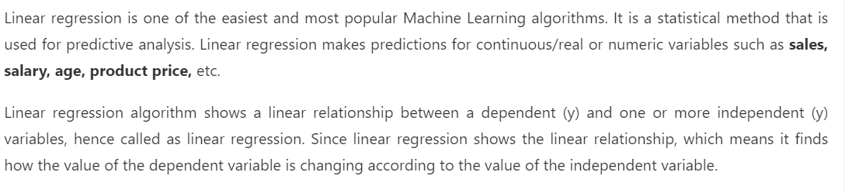

Types of relation possible

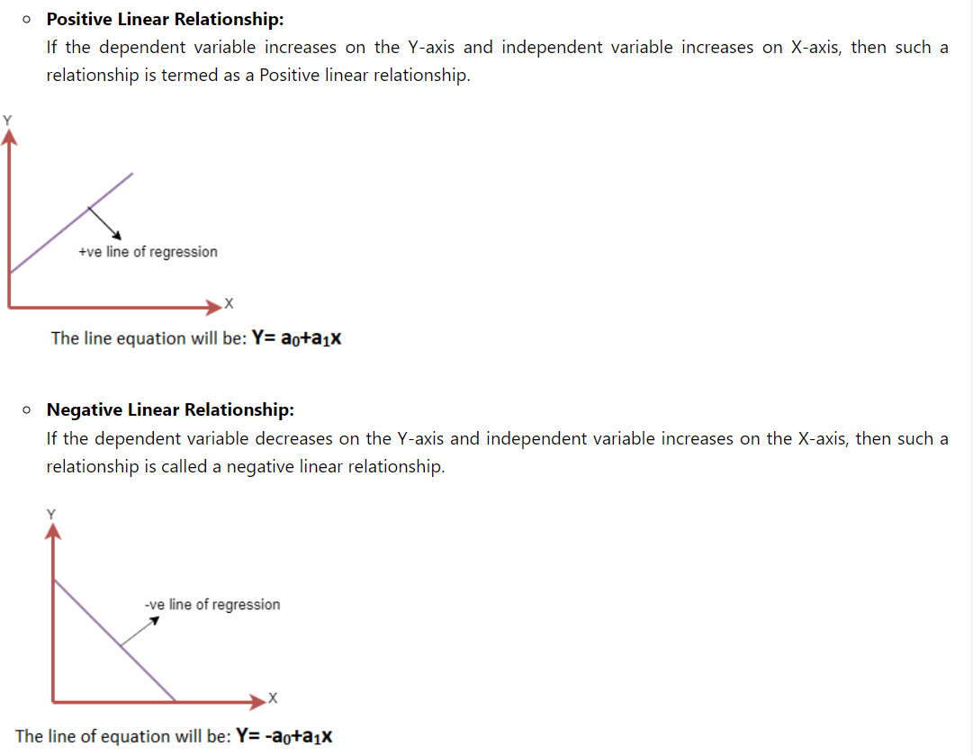

**Calculation of m and c ie slope and constant**

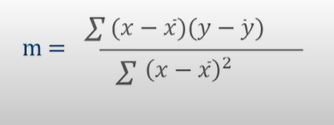

**X bar is mean of x and similarly for y**

**Substitute value of m in**

**Mean_y=mean_x*m+c**

**To get the regression line**

**Use mean square error method**

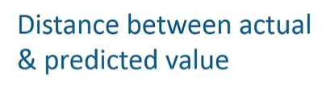

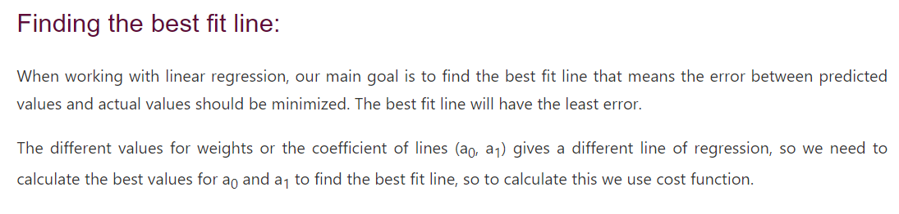

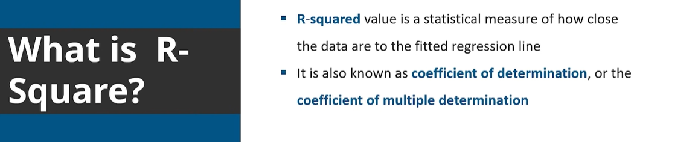

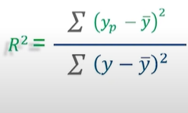

**Libraries used in linear regression:-**

**Mathematically**

**🡪np, pd , matplotlib, mathematical logic**

**ML Libraries**

**🡪SKlearnKit**